

Lab Manual- Create, query, and traverse an Azure Cosmos DB graph database using the Gremlin console

Prepared for:

Date: 18th Nov 2021

Prepared by:
Document Name: Lab Manual Document Number AZLab309
Contributor:

Contents
1. Introduction 3
2. Gremlin Console 3
3. Create an Azure Cosmos DB Account with Graph API 3
4. Add a Graph 8
5. Download and Install Gremlin Agent 10
5.1 Step1: 10
5.2 Step2: 13
6. Configure Remote-secure.yaml file 14
7. Connect to your CosmoDB/Graph 16
8. Create vertices and edges 17
1. Let's begin by adding five person vertices for Thomas, Mary Kay, Robin, Ben, and Jack. 17
2. Next, let's add edges for relationships between our people. 18
9. Update a vertex 18
10. Query your graph 19

Introduction
Azure Cosmos DB is a Microsoft Azure database service, fastest-growing Azure service that is available in all Azure regions, that fits any web application, mobile application, gaming or IoT application that requires processing, reading and writing a massive amount of data.
This Lab will help you to create an Azure Cosmos DB Gremlin API account, database, and graph (container) using the Azure portal and then use the Gremlin Console from Apache TinkerPop to work with Gremlin API .

Gremlin Console
The Gremlin console is Groovy/Java based and runs on Linux, Mac, and Windows. You can download it from the
https://tinkerpop.apache.org/download.html
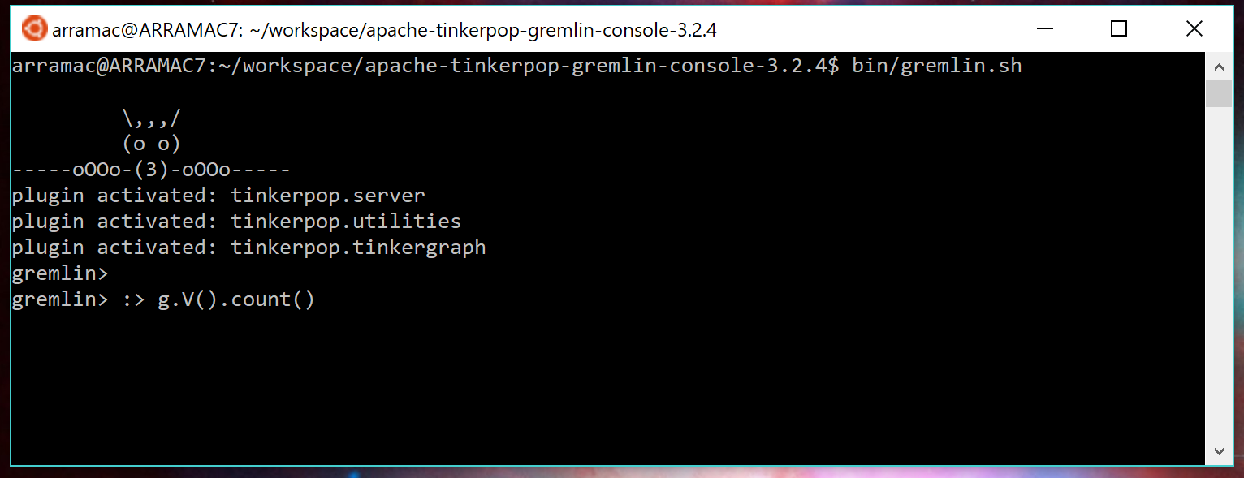
You can also download it from CosmoDb Console

Create an Azure Cosmos DB Account with Graph API
- In a new browser window, sign in to the Azure portal.
- Search or select Azure ComsoDB

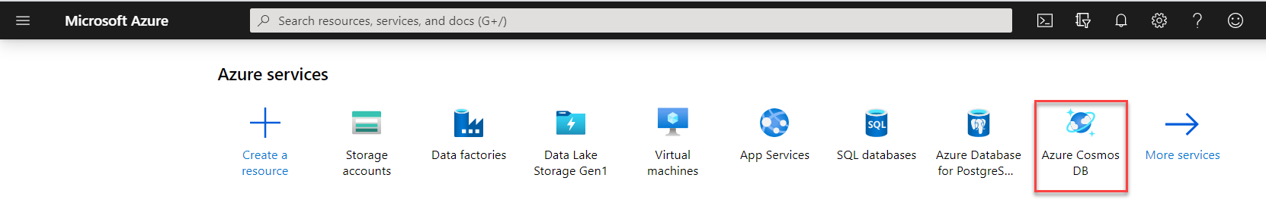
- In the opened page, click on the Create Azure Cosmos DB account option, to create a new Cosmos DB account, as shown below:
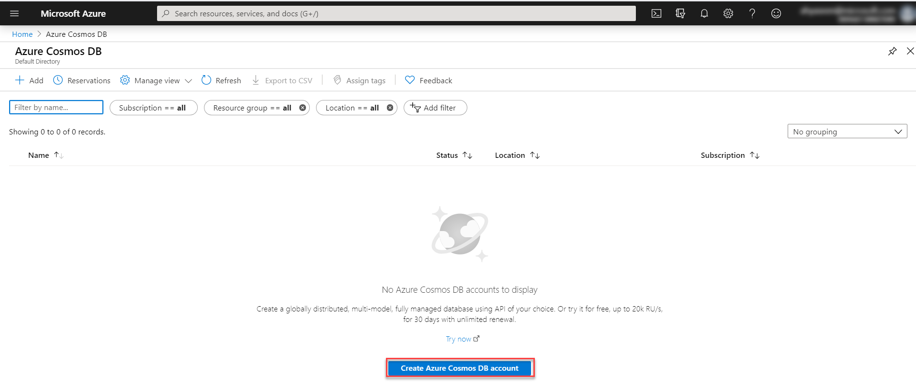
- Select API Gremlin and click Create Button
- From the Create Azure Cosmos DB Account page, select the Azure subscription under which you plan to create the Cosmos DB account and the resource group.
- Select your region and Leave all option default
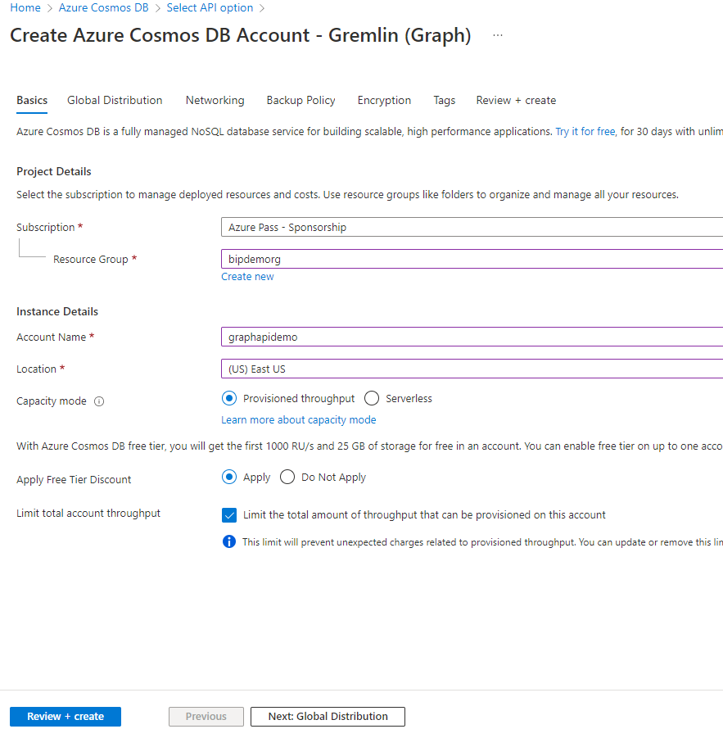

- After providing your selections click on Review + Create .
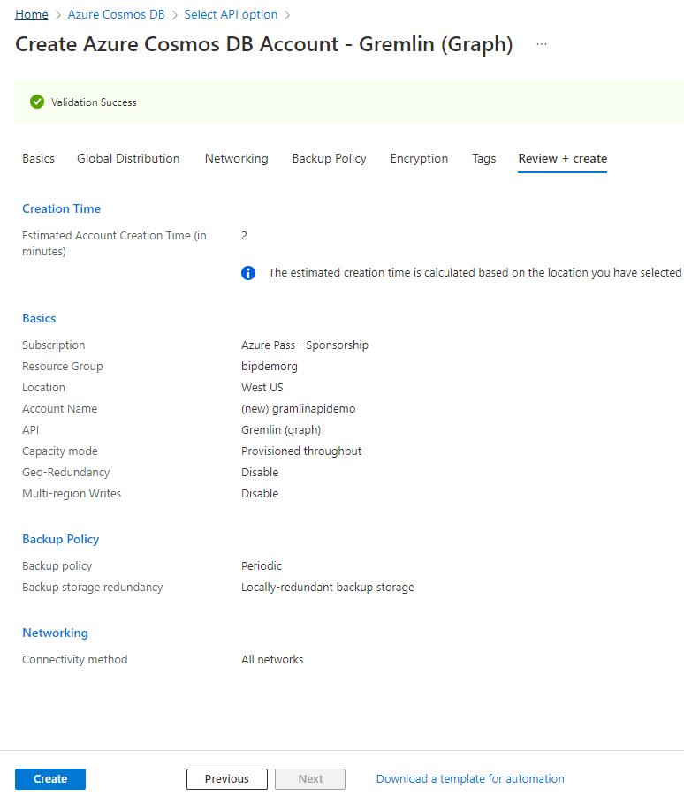
- In the Review + Create page, review all the selections then click on the Create option to create your Azure Cosmos DB account
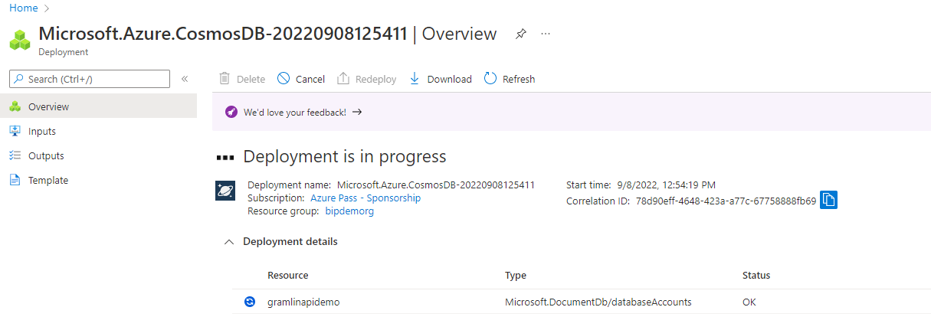

- After a few minutes, the database account will be created and deployed completely. Click on the Go to resource option to start working in the database account, as shown below:
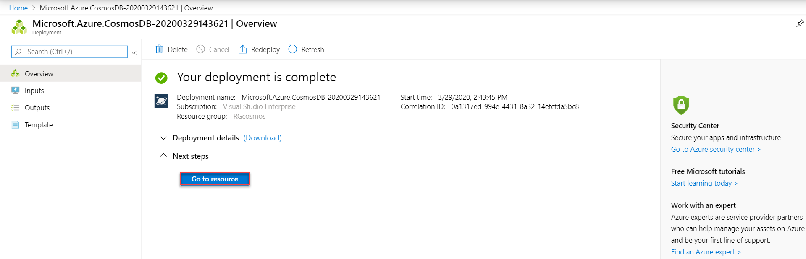
- The first opened page is the Quickstart page that allows you to select from the available platforms and the next step to proceed with the Azure Cosmos DB account. Click on the Overview page from the below:
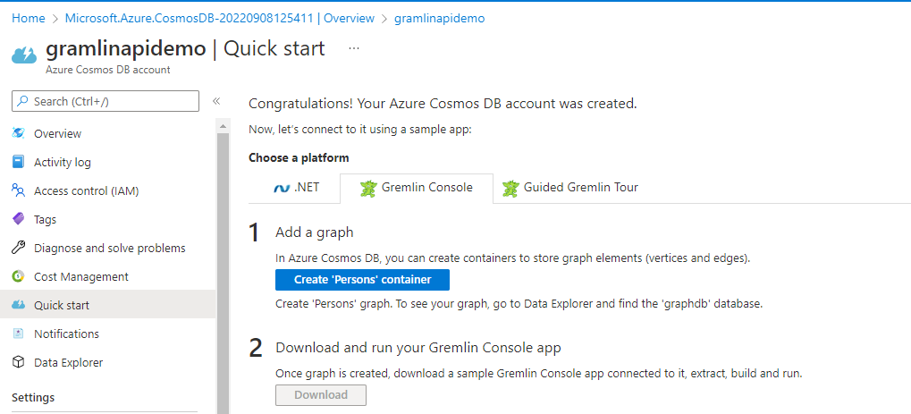

Add a Graph
You can now use the Data Explorer tool in the Azure portal to create a graph database.
- Select Data Explorer > New Graph.
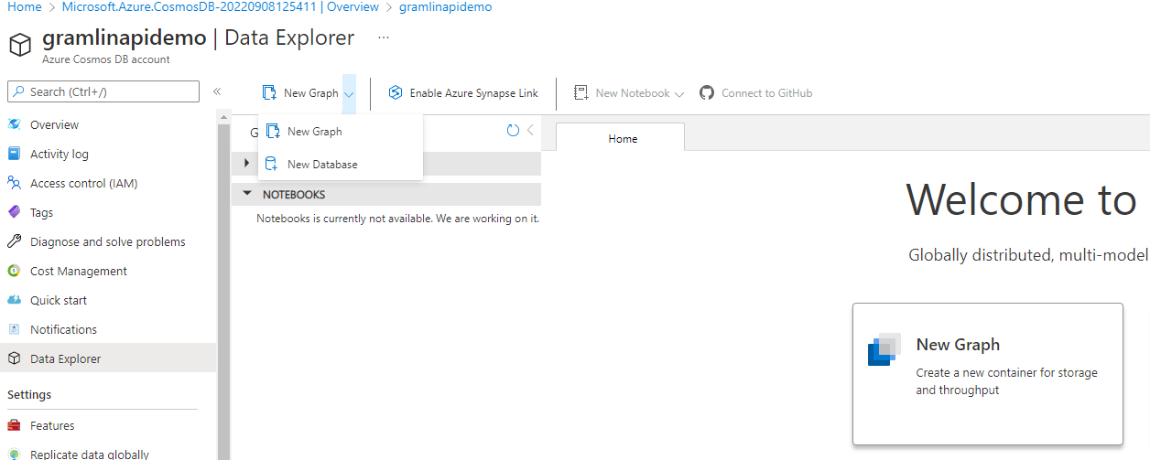
- In the Add graph page, enter the settings for the new graph.
Setting | Suggested value | Description
Database ID | sample-database | Enter sample-database as the name for the new database.
Throughput | 400 RUs | Change the throughput to 400 request units per second (RU/s).
Graph ID | sample-graph | Enter sample-graph as the name for your new collection.
Partition Key | /pk | All Cosmos DB accounts need a partition key to horizontally scale..
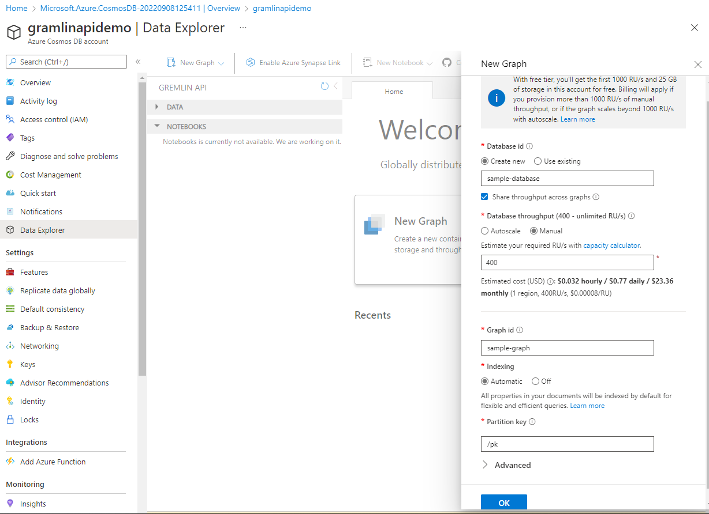
- Once the form is filled out, select OK and you will get screen similar to below.
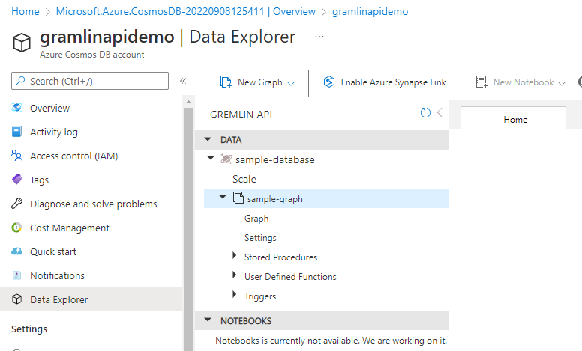

Download and Install Gremlin Agent

Step1:

Download the Gremlin Installer from this website
https://www.gremlin.com/community/tutorials/how-to-install-and-run-gremlin-on-windows/

Click the MSI to begin the installation and follow the wizard
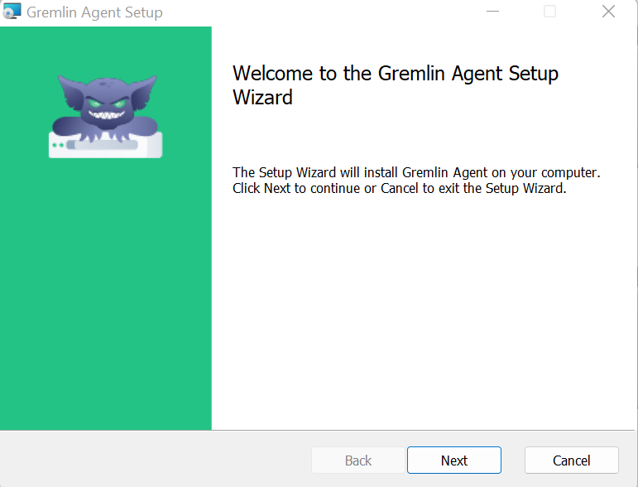

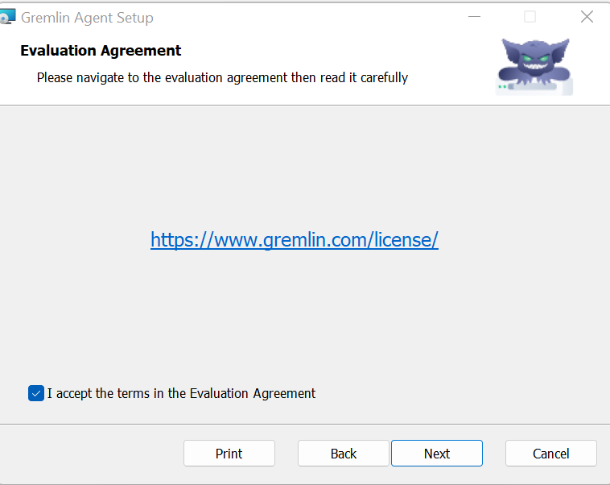

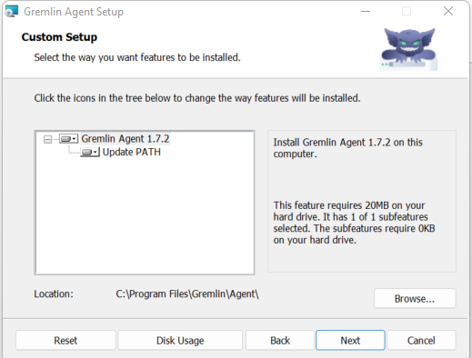

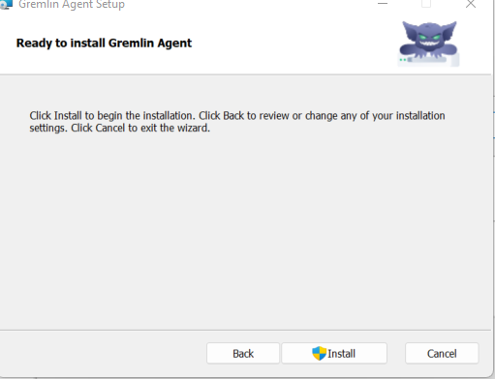

- A dialog box asking to escalate privileges may be displayed. Click Yes.

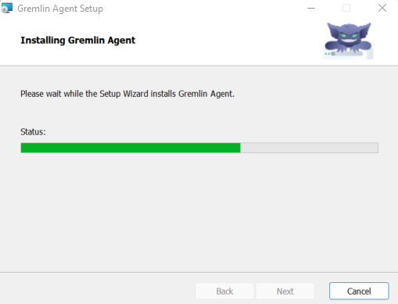\

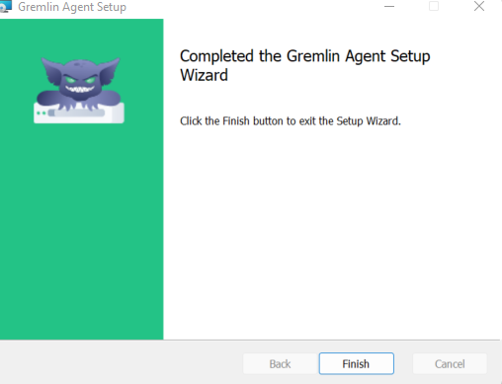

Step2:

Create Persons Container

Download the Gremlin Installer from this CosmoDB Quick start

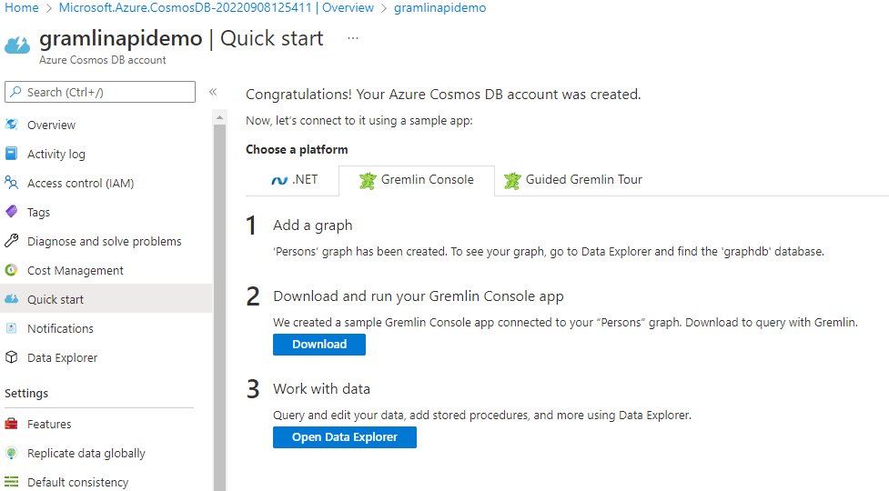

Once the Download Complete , extract the Zip and Copy the Folder to C:\

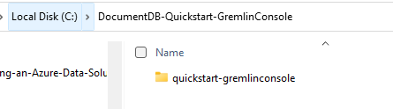

Configure Remote-secure.yaml file
- Before starting the Gremlin Console, create or modify the remote-secure.yaml configuration file in the apache-tinkerpop-gremlin-console-3.2.5/conf directory.
- Fill in your host, port, username, password, connectionPool, and serializer configurations as defined in the following table:
Setting | Suggested value | Description
hosts | [account-name.gremlin.cosmos.azure.com] | See the following screenshot. This is the Gremlin URI value on the Overview page of the Azure portal, in square brackets, with the trailing :443/ removed. Note:
port | 443 | Set to 443.
username | Your username | The resource of the form /dbs/<db>/colls/<coll> where <db> is your database name and <coll> is your collection name.
password | Your primary key | See second screenshot below. This is your primary key, which you can retrieve from the Keys page of the Azure portal, in the Primary Key box. Use the copy button on the left side of the box to copy the value.
connectionPool | {enableSsl: true} | Your connection pool setting for TLS.
serializer | { className: org.apache.tinkerpop.gremlin.  driver.ser.GraphSONMessageSerializerV2d0,  config: { serializeResultToString: true }} | Set to this value and delete any \n line breaks when pasting in the value.
For the hosts value, copy the Gremlin URI value from the Overview page:
For the password value, copy the Primary key from the Keys page:

Your remote-secure.yaml file should look like this. Save the File.
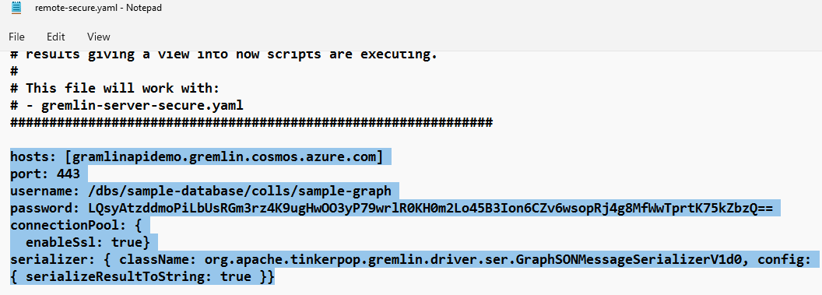

Connect to your CosmoDB/Graph
- In your terminal, run bin/gremlin.bat or bin/gremlin.sh to start the Gremlin Console

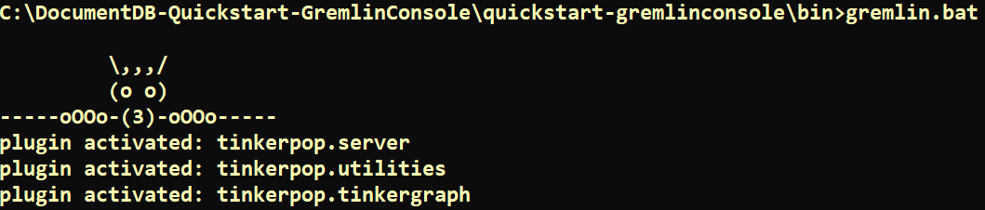

- In your terminal, run :remote connect tinkerpop.server conf/remote-secure.yaml to connect to your app service.

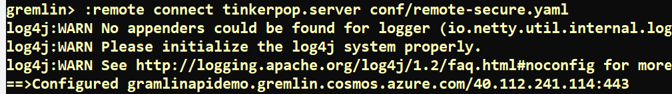

- Next run :remote console to redirect all console commands to the remote server.
- Let's try a simple count() command. Type the following into the console at the prompt
g.V().count()
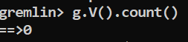

Create vertices and edges

Let's begin by adding five person vertices for Thomas, Mary Kay, Robin, Ben, and Jack.
Input (Thomas):
g.addV('person').property('firstName', 'Thomas').property('lastName', 'Andersen').property('age', 44).property('userid', 1).property('pk', 'pk')

Input (Mary Kay):
g.addV('person').property('firstName', 'Mary Kay').property('lastName', 'Andersen').property('age', 39).property('userid', 2).property('pk', 'pk')
Input (Robin):
g.addV('person').property('firstName', 'Robin').property('lastName', 'Wakefield').property('userid', 3).property('pk', 'pk')
Input (Ben):
g.addV('person').property('firstName', 'Ben').property('lastName', 'Miller').property('userid', 4).property('pk', 'pk')
Input (Jack):
g.addV('person').property('firstName', 'Jack').property('lastName', 'Connor').property('userid', 5).property('pk', 'pk')
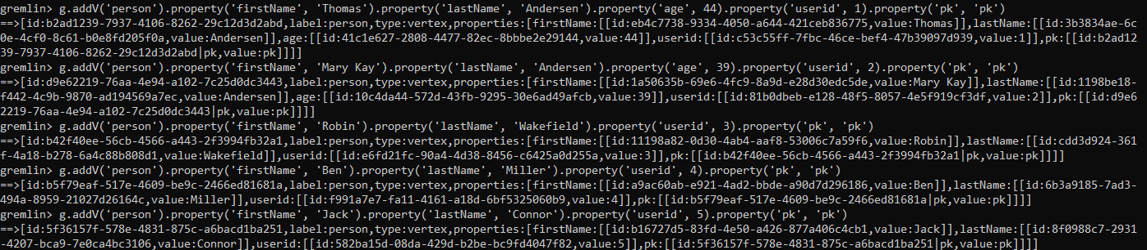

Next, let's add edges for relationships between our people.

Input (Thomas -> Mary Kay):
g.V().hasLabel('person').has('firstName', 'Thomas').addE('knows').to(g.V().hasLabel('person').has('firstName', 'Mary Kay'))
Input (Thomas -> Robin):
g.V().hasLabel('person').has('firstName', 'Thomas').addE('knows').to(g.V().hasLabel('person').has('firstName', 'Robin'))
Input (Robin -> Ben):
g.V().hasLabel('person').has('firstName', 'Robin').addE('knows').to(g.V().hasLabel('person').has('firstName', 'Ben'))
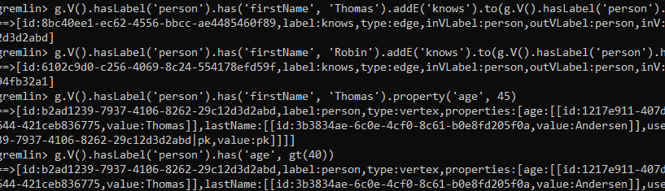

Update a vertex
Let's update the Thomas vertex with a new age of 45.
g.V().hasLabel('person').has('firstName', 'Thomas').property('age', 45)
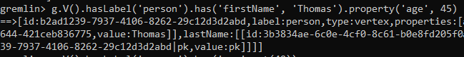

Query your graph

First, let's try a query with a filter to return only people who are older than 40 years old.
Input (filter query):
g.V().hasLabel('person').has('age', gt(40))
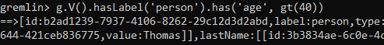
Next, let's project the first name for the people who are older than 40 years old.
Input (filter + projection query):
g.V().hasLabel('person').has('age', gt(40)).values('firstName')

